SOFTWARE REQUIREMENTS

|  |  |
| --- | --- |
| **TEAM ID** | PNT2022TMID16047 |
| **PROJECT NAME** | Hazardous area monitoring for industrial plant powered by IOT |

INSTALLATION OF PYTHON SOFTWARE

STEP 1: Installing the python

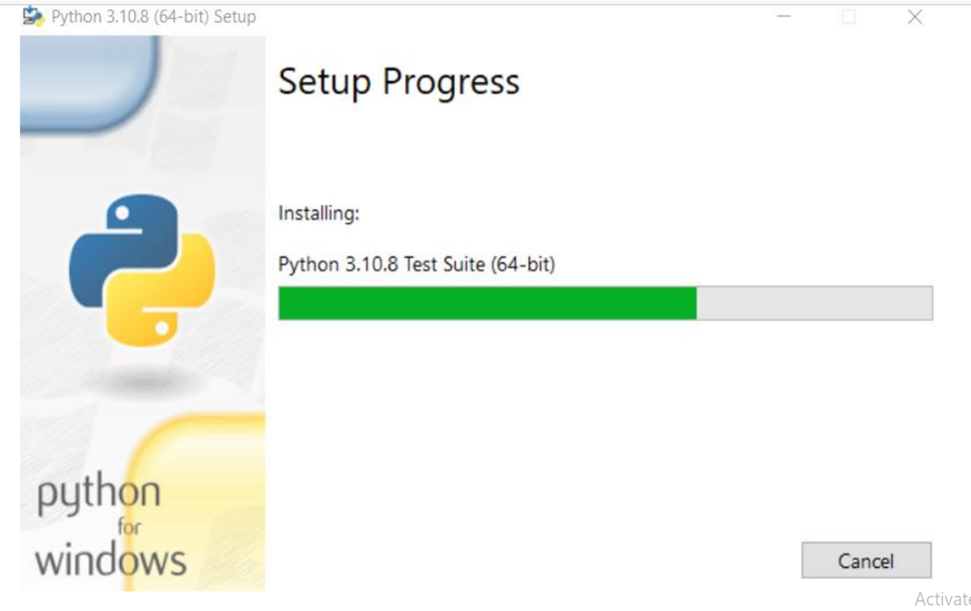

STEP 2: set up the process in their respective desktop

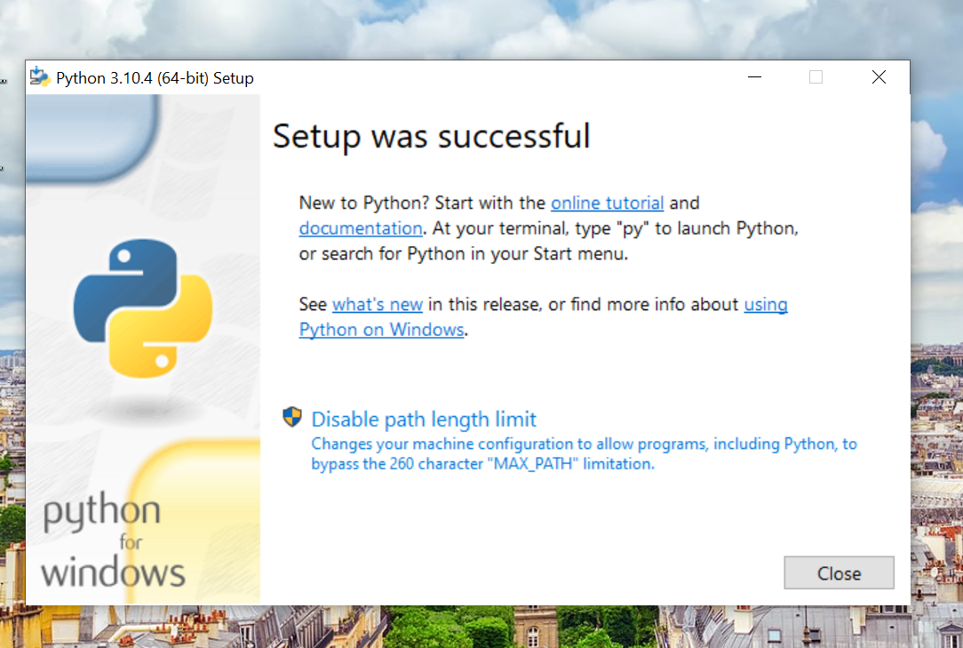

STEP 3: Python IDLE shell appear

